1. Creating a deployment

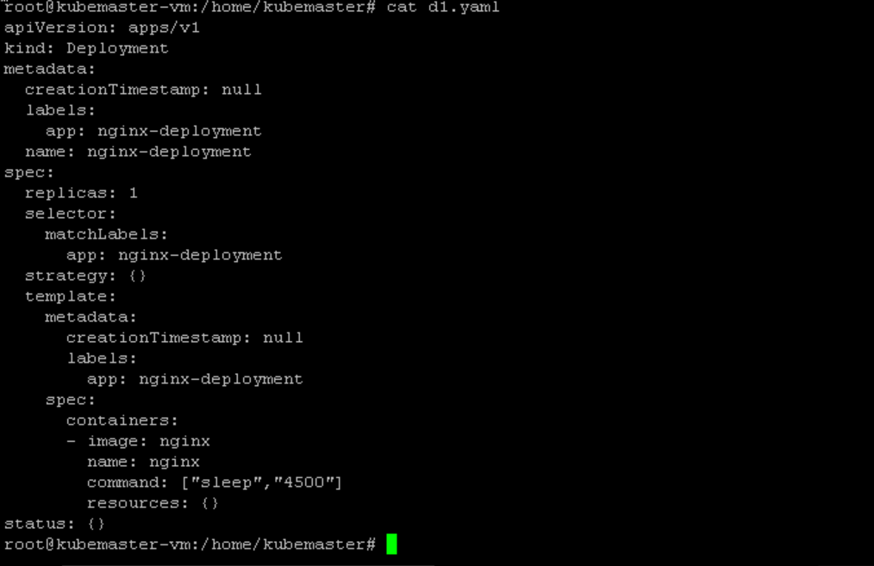

* Also create deployment using a command
  + Command:
    - Kubectl create deploy nginx-deployment --image=nginx
    - Can also create yaml file from this using below command
    - Kubectl create deploy nginx-deployment –image=nginx –dry-run=client -o yaml >d1.yaml

1. Now I want to apply the deployment to create the deployment



1. The deployment created is:

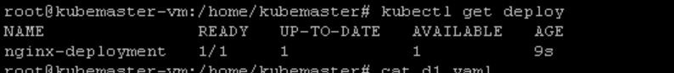

Command used: kubectl get deploy

1. Created a service using the command



Command: kubectl expose deploy nginx-deployment –port=81 –target-port=80 –type=NodePort –dry-run=client -o yaml >service.yaml

1. Cat service.yaml

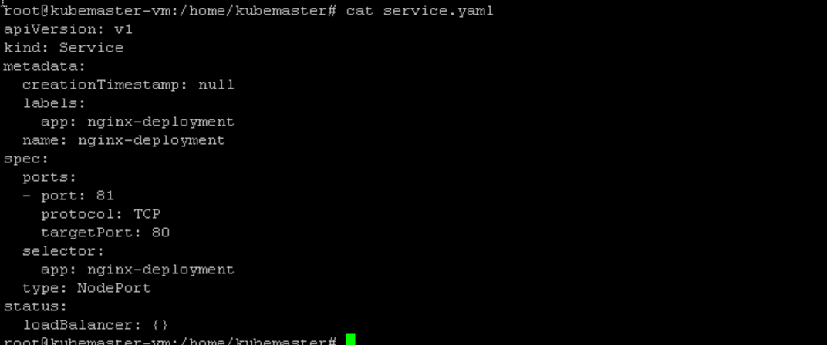

1. Created a service using apply command

Command: kubectl apply -f service.yaml



1. To see the service created

Command: kubectl get svc

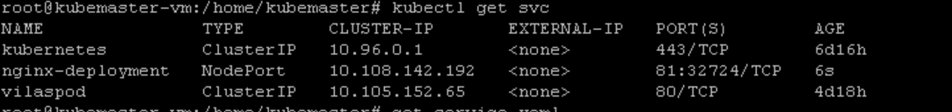

1. Status of deployment and service : both are ready
   1. I used nodeport so it internally creates the clusterIP

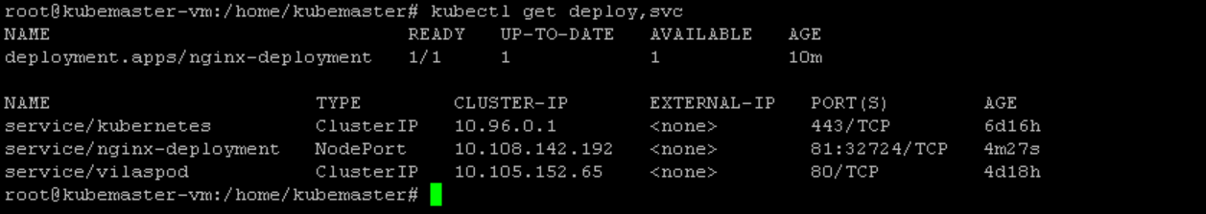

1. Pods



1. I tried to curl the nodeport service using both port but still getting connection refused..
   1. The ports are not open I think so in my machine

